 | MULTIPLE DISTRICT 105  YOUNG AMBASSADOR  OF THE 21st CENTURY | 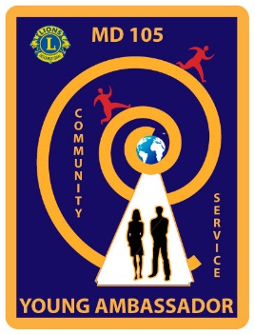

APPLICATION FORM
(Please complete on computer or hand-written in BLACK)

Candidate’s name, address, email and telephone number

Date of birth

Sponsoring Lions Club, contact name, email and telephone number

PARENT/GUARDIAN’S APPROVAL
I certify that my son/daughter may attend the following:
1. Multiple District 105 Final of the Young Ambassador of the 21st Century
If the winner of the Multiple District Final
2. Lions Multiple District Convention
3. European Final, held at Europa Forum in one of the European member countries
4. Next year’s Multiple District Final to support the candidates and help organise the
weekend
5. If eligible, a residential Youth Centre, either in the UK or overseas.

Signature of parent/guardian: ______________________________________

LETTER OF SUPPORT
The candidate should enclose a copy of a letter of support for their entry from an organisation they have nominated to receive the bursary.

Signature of organisation’s representative: ___________________________

ADDITIONAL INFORMATION
On separate sheets, the candidate should enclose the following information with this application:

Section 1: COMMUNITY INVOLVEMENT – details of all their welfare work.

Section 2: HOBBIES, INTERESTS, etc.

Signature of Applicant ______________________________________________________
USE OF THE BURSARY - This plan should include details of how you would spend the £500
bursary. A further separate bursary plan must be submitted for the additional £1,000 you may win as MD winner – see following page.

Aim of the use of the £500 bursary, including details of the group/s to be helped – please continue on a separate sheet if more space is required

Items to be bought/services provided | Estimated Cost | Actual  Cost
1.
2.
3.
4.
5.
6.
Total

The Lions Club of ……………………………. understands that it is a requirement that the authorisation for use and administration of this £500 bursary should be undertaken by the sponsoring Lions Club, if their candidate has won the District Final and is therefore a participant at the Multiple District Final.

Signed ………..…………………………… President. Signed ………………………………….. Treasurer

This is to be completed by District Finalists and will be submitted should you reach the Multiple District Final.
Aim of the use of the £1,000 bursary, including details of the group/s to be helped – please continue on a separate sheet if more space is required

Items to be bought/services provided | Estimated Cost | Actual  Cost
1.
2.
3.
4.
5.
6.
Total

The Lions Club of ……………………………. understands that it is a requirement that the authorisation for use and administration of this £1000 bursary should be undertaken by the sponsoring Lions Club, as the winning candidate at MD Final signs their agreement to this condition.

Signed ………..…………………………… President. Signed ………………………………….. Treasurer

